**1)AWS ECS**

* Container orchestration service
* Manage whole life cycle of containers
* In ECS, ECS cluster contains services to manage containers

Cluster

* A logical grouping of your ECS tasks, services, and other resources in an AWS region.

ECS with Fargate

* Alternative to EC2 instances
* Fargate is the serverless way to manage containers
* No need to provision and manage servers

ECS Task Definition:

* A JSON file describing the properties of containers that will run on ECS, such as docker image, ports, CPU, memory, IAM role, logging etc..
* Task definition specifies which containers are included in your task and how they interact with each other. You can also specify data volumes for your containers to use
* If you need to update current task definition you need to choose option “Create new revision” under task definition

Task Execution IAM Role:

* This role is required by tasks to pull container images and publish container logs to Amazon CloudWatch on your behalf. If you do not have the ecsTaskExecutionRole already, we can create one for you.

ECS Service:

* It allows you to maintain a desired number of tasks running
* If any of the tasks fail ,the amazon ECS service scheduler creates a replacement task to keep the number.
* A service lets you specify how many copies of your task definition to run and maintain in a cluster. You can optionally use an ELB to distribute incoming traffic to containers in your service.
* You can attach an application load balancer to your ECS service and distribute traffic to your ECS tasks.
* For using multiple tasks we can use Service type : Replica
* There is mainly two types of deployments: Rolling update and Blue/green

Load balancing:

* An Elastic load balancing load balancer distributes incoming traffic across the tasks running in your service. Load balancer type: Application LB, Network LB, Classic LB
* We can add load balancer inside our service tab.

Auto-scaling:

* Automatically adjust your services desired count up and down within a specified range in response to CloudWatch alarms

AWS ECS : Fargate:

* Fore serverless deployments we don’t need to worry about EC2 Instances

**2)AWS EKS**

* Managing Kubernetes cluster on AWS
* Alternative to ECS

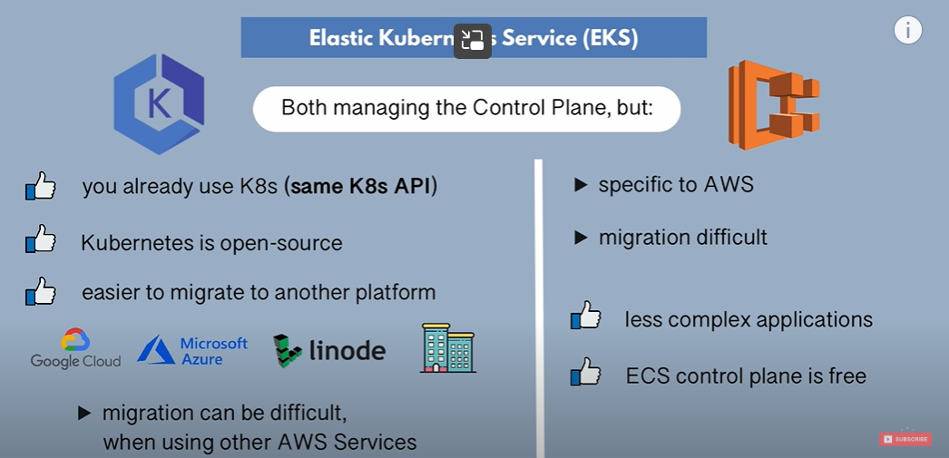

* EKS Deploys and manages Kubernetes Master nodes

